Contents

OS/Disk level settings 1

SQL Server level settings 1

DB level settings 2

Observations 2

Findings 3

Mainitainance Jobs 4

Tuning (Query Slowness,Timeouts,ApplicationSlow,Blockings,SP TakesTime 5

About Myself……….………………………………………………………………………………………………………………………..6

**OS/Disk level settings:**

Temp db: Create temp db file(s) based no of processors. Suppose if you have 4 processors create 4 tempdb files. BUT DON’T CRAETE MORE THAN 8 FILES.

Try to keep separate drive for datafiles, logfiles and tempdb and backups files (minimum 5 drives +1 OS(C-drive) required)

Try to create Separate file groups for all nonclustered indexes and Big tables. This way we can reduce IO operations. I mean we need to make IO traffic balanced. Check below doc for more info



And try to implement, Instant file initialization for the SQL Server Machines. This makes Backup and restore become faster. Even this also makes DB Autogrowth faster.

<https://www.sqlshack.com/sql-server-setup-instant-file-initialization-ifi/>

**SQL Server level settings:**

sp_configure 'show advanced options',1

RECONFIGURE

* backup compression default--Make Run value is 1 for the below configurations
* max degree of parallelism-- If you have more than 8 processors in the system, make this 8 else case try to keep as it is. I mean don’t change this default value.
* max server memory (MB)-- You must give 20% memory to the OS, remaining 80% give to the SQL server. (look into this https://www.sqlservercentral.com/blogs/suggested-max-memory-settings-for-sql-server-20052008)
* optimize for ad hoc workloads-- If you are running more adhoc queries, make this 1 or else it's fine

**DB Level Settings:**

* Make sure below DB settings correctly configured. Below all settings are very important.

Compatibility setting should be latest version. Latest version will always equal to the current SQL Version installed.

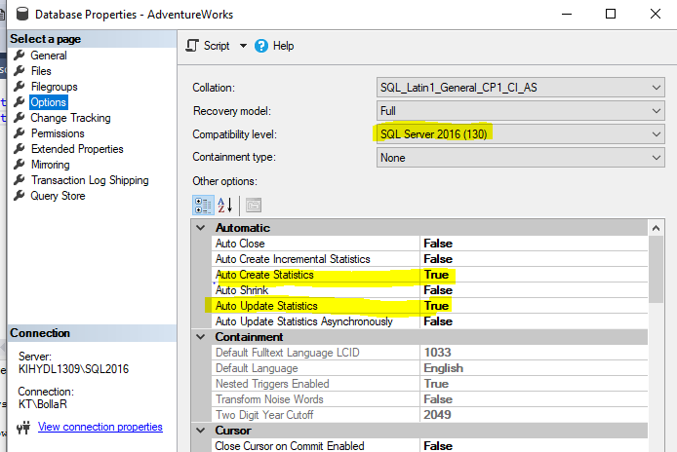

**Observations:**

Keep an eye on below logs. If any error is frequently getting logged. Try to fix ASAP. If not, it impacts the performance of the server. Checking on each server is tough. So, try to make automate, if any errors are logged each day. I have couple of scripts to automate this depend on the need. Just talk with me for more info.

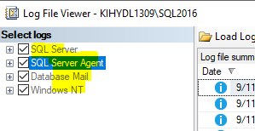

**Findings:**

Duplicate indexes: Without second thought, remove the duplicate indexes. Below script(Exact duplicates) is useful to find the duplicate indexes on each database.



Unused indexes: Try to delete Unused indexes (not all at least top 10). Just keep on eye on this. Better to note down or dump to the table the unused indexes on weekly basis. If same indexes are repeating every week/month, you can safely delete them. At least one-month observation required on this.

Missing indexes:

Try to create Missing indexes (not all at least top 10). Just keep on eye on this. Better to note down or dump to the table the Missing indexes on weekly basis. If same indexes are repeating every week/month, you can safely create them. At least one-month observation required on this.

**Maintenance Jobs:**

Maintenance jobs are very important. My best recommendation is use ola script. Main reasons to use Ola scripts are

* We can have better track
* Build indexes based on fragmentation and no of pages
* Less chances to fail the job and each job runs faster than any other conventional jobs

Statistics are very important. Up to date statistics, will reduce lock->blocks->deadlocks->Gain performance. Believe me, if you are seeing more blocks and deadlocks in your system for different processes, defiantly an issue with statistics. How you gonna check this is. Just run the below query on any sample tables. If ROWS and ROWSSAMPLE are same then statistics are good and up to date. If more gap means more bad statistics. STATISTICS WILL PLAY A CRUSIACL ROLE FOR GENERATING A GOOD and EFFECTIVE PLAN.



**Tuning:**

<Once above all settings are fine. You can work on this item> Identify what type of performance issue your system is having. Issues may be CPU Pressure, Memory pressure and IO Pressure.

Depend on issue below query will be useful.



Just note:

* Try to maintain clustered index on each table key column(s): This will reduce Table scan/RID lookup. If you don’t have clustered index on large tables, this leads to CPU pressure.
* Try to create non-clustered index on each foreign key columns.
* Think about Data purging and Data Archiving and Data partitioning on Large tables
* If your database is high OLTP then try to implement ReadCommittedSnapshot ON for the Databases.

**How to tune current running queries/At present-slowness of the Server/Timeouts at present/End user complaining his query was slow ?**

I am really fond of using below SP(You can download from google <http://whoisactive.com/>). This Sp will give all current active running sessions. Using this, we can quickly say the performance of the server. We can also pass some parameters to know about more details on the sessions too.

To understand SP_whoisactive, just run the below query.

Sp_whoisactive @help=1

Coming to main topic, for any slowness just check with the below query. This will give the all the current running queries including with their plans. Just tune these queries by going through these plans. Even for blockings, try to tune the lead blocker so that next time very less chances are there for getting involved into the same blocking scenario.

sp_whoisactive @get_plans = 1

If you don’t want to keep SP_WHOISACTIVE, below query will give almost equal results



**How to tune a SP:**

For tuning any SP, just use below query. This will give the execution plan of the that SP



**Note:**

Try to capture all the SP execution timings in a table every day. Create a job for this. Hardly it takes 30 sec to capture all the SP execution details. This data will be useful for DBA to set the trends. Even we can agree or disagree to the people who always complains on the slowness. This makes us better proof for everything.

**Just note, don’t try to implement all the above things at a time. Implement each one by one every week and give a gap of one week. This way you can clearly the observe the performance of the each above item.**

Myself, I am a freelancer. You can reach me for any kind of solution(s) in SQL Server and Azure. The best compliments, I got till now is, I am good at performance Tuning and Automation of manual Tasks. If I get a chance, I want to hear same from you too. For more information contact me on +91-9966246368 (whatsapp) and mail- [rajasekharreddyb.dba@gmail.com](mailto:rajasekharreddyb.dba@gmail.com) and skype RajasekharBolla

I have below solutions with me, if you are looking for same reach out to me.

* Daily server Report (which will send daily mail about, DB sizes, JOB STATUS, SQL ERROR LOG DETAILS, JOBS DISABLED /SCHEDULE DISABLED, Daily Backup sizes& Time & path)
* Blocked Process Alert (Which will send mail, if any blocks are occurred)
* Deadlock Alerts (Which will send mail, if any deadlock is occurred)
* Diskspace Alerts (Which will send mail, if any diskspace is below threshold value)
* Login Changes Alert (Which will send mail, if any new login added, drooped/changed)
* DB changes Tracking Alert (If anybody changes the recovery of the database or any properties of the DB, same will get on automated mail)
* Daily report(s) through excel data (Any business data you want to see in the email daily/weekly)
* Helping on Table Data Archive/Purging/Partitioning
* Automated backup and Restore (It will refresh nonprod’s databases with prod automatically and sends the mail once this is done. It saves the lot of time of DBA’s)
* Missing Index Details & Unused Index Details & Duplicate Index Details Tracking (This will store the missing index details, Unused Index Details data and Duplicate Index Details data to a table)
* Tracking all stored Procedures statistics (Total execution time and Time when it got executed, frequency of execution, etc. every day/week)
* Performance counters setup-To track the server performance
* Real time issues and solutions
* DBA interviews Training
* Complete hand-written SQL DBA Notes.  
  In Addition,  
  If anybody wants training on SQL Azure/SQL DBA/Development/Performance tuning or any specific topic, I can help you.

===ALL THE BEST===